**TASK-3**

**Basic Vulnerability Scan on PC using Nessus**

1. Go to the official Tenable website - <https://www.tenable.com/products/nessus/nessus-essentials>
2. You'll need to provide your name and email address and click on Get Started

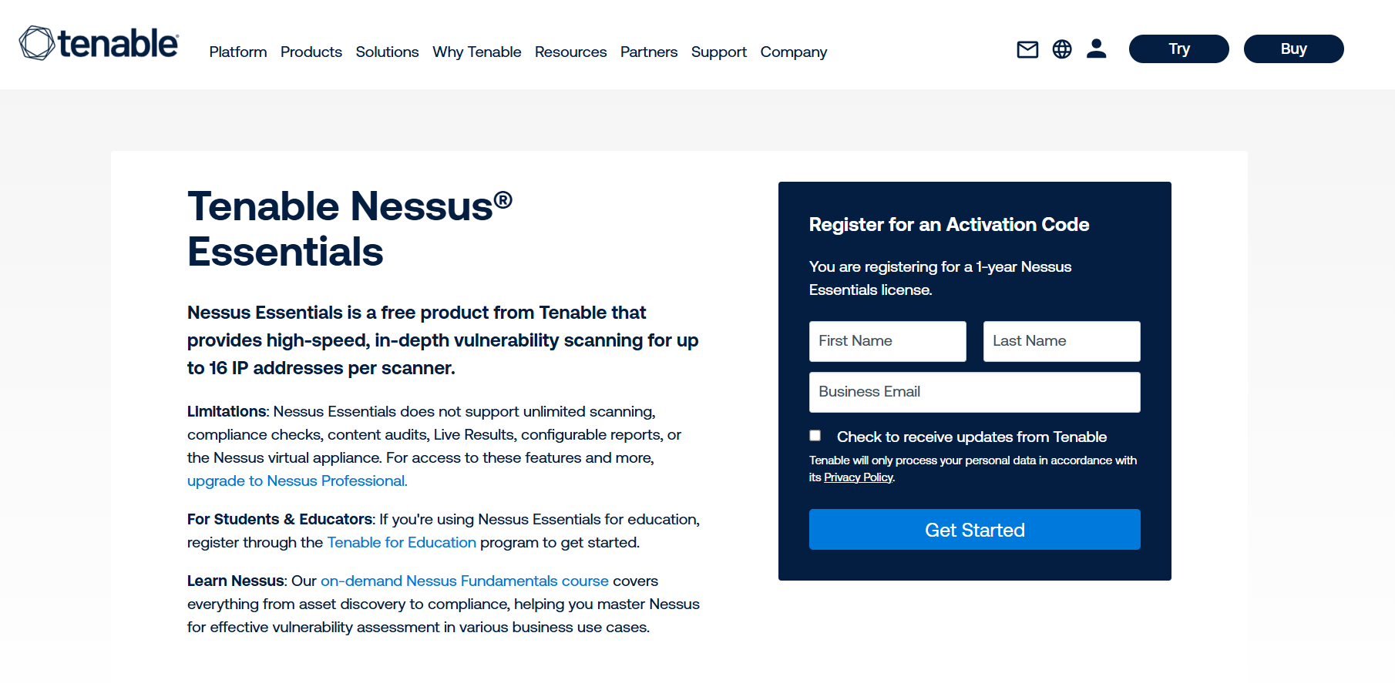

1. An email with an activation code will be sent to your email address. Save it for later.
2. Now, run the file as administrator.



1. After the installation process, your default web browser should automatically open to the Nessus web interface (usually <https://localhost:8834/>)
2. You may encounter a "Connection is not private" or "Security warning" because Nessus uses a self-signed SSL certificate initially. You'll need to bypass this warning (e.g., click "Advanced" then "Proceed to localhost" or "Accept the risk")
3. On the welcome screen, select "Nessus Essentials."
4. Enter the activation code you received via email.
5. Create an administrator account (username and password) for accessing the Nessus web interface
6. After setting up the admin account, Nessus will begin downloading and compiling its plugins. (Time consuming process)

**Full Scan**

Now Click on the New Scan button

Click on the Basic Network Scan for a Full system scan

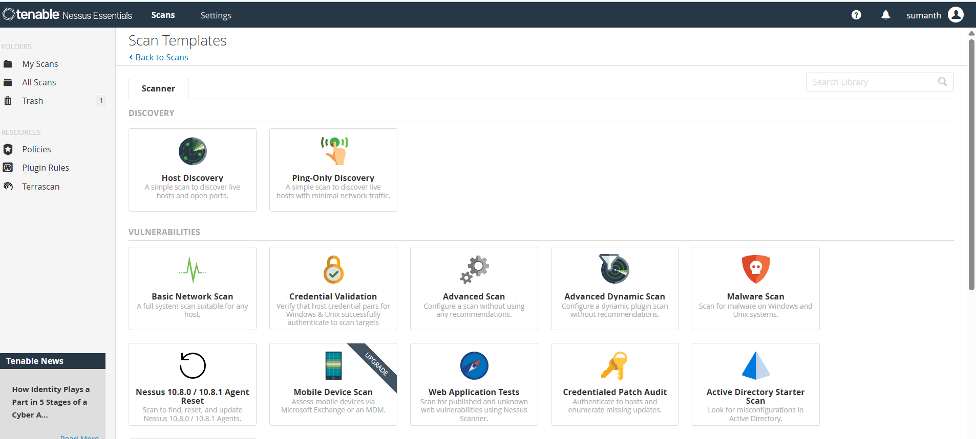



Give the target to scan and wait some time for the scan to be completed.

After completion of scanning my network there are no critical vulnerabilities present.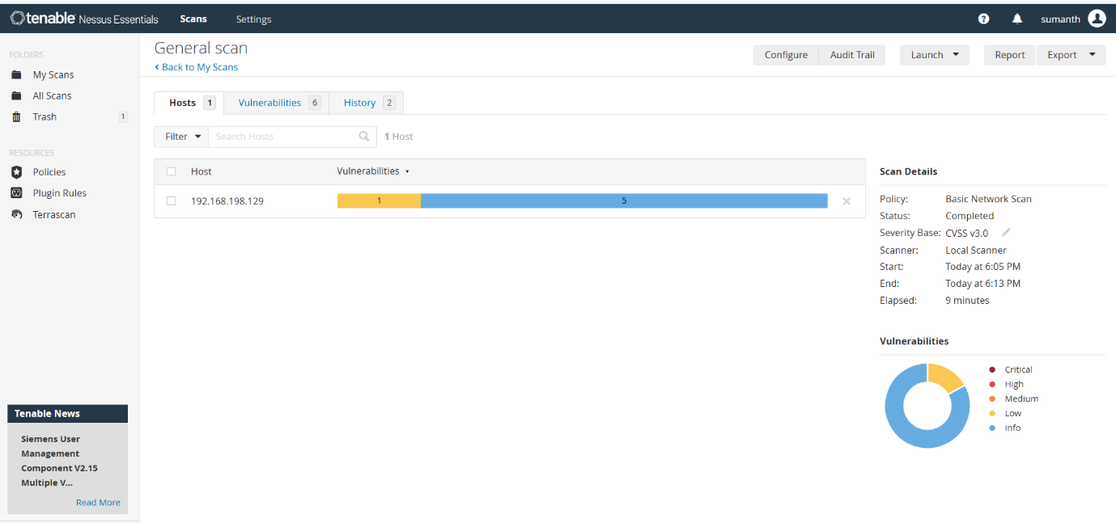

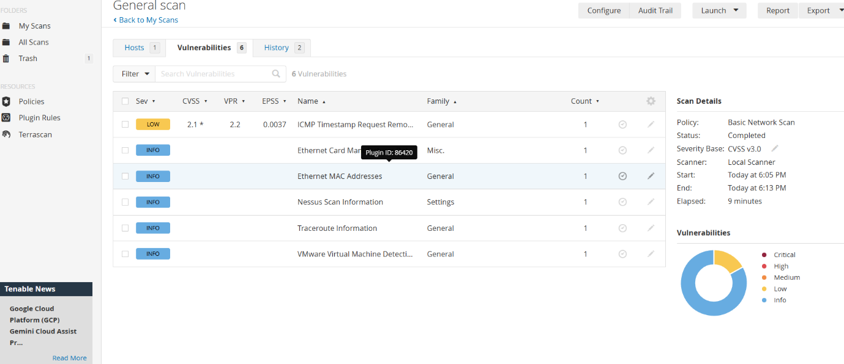

Mitigation for the ICMP timestamp:

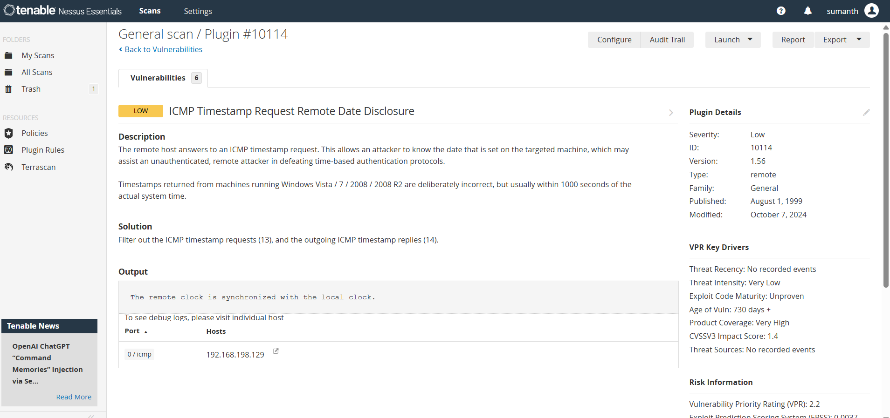

**Plugin Details**

Severity:Low

ID:10114

Version:1.56

Type:remote

Family:General

Published:August 1, 1999

Modified:October 7, 2024